**01)**

**Source Code:**

StudentList class:

import java.util.Arrays;  
  
public class StudentList {  
 private int maxSize ;  
 private int position;  
 private Student[] ListEntry;  
  
 public StudentList(int size){  
 maxSize = size;  
 ListEntry = new Student[maxSize];  
 position= -1;  
 }  
  
 public boolean IsListEmpty(){  
 return (position==-1);  
 }  
  
 public boolean IsListFull(){  
 return (position== maxSize-1);  
 }  
  
 public int ListSize(){  
 return (position+1);  
 }  
  
 public void InsertLast(Student student){  
 if (IsListFull())  
 System.*out*.println("Attempt to insert at the end of a full list");  
 else  
 ListEntry[++position] = student;  
 }  
  
 public void InsertList(int p, Student student){  
 int i;  
 if (IsListFull())  
 System.*out*.println("Attempt to insert an entry into a full list");  
 else if (p < 0 || p > ListSize())  
 System.*out*.println("attempt to insert a position not in the list");  
 else  
 {  
 for( i = ListSize(); i >p; i--)  
 ListEntry[i] = ListEntry[i-1];  
 ListEntry[p] = student;  
 position++;  
 }  
 }  
 public Student RetrieveList(int index){  
 Student student;  
 if (IsListEmpty()){  
 System.*out*.println("List is empty");  
 return null;  
 } else if(index < 0 || index >= ListSize()){  
 System.*out*.println("Out of list size. Enter a valid index.");  
 return null;  
 } else {  
 student = ListEntry[index];  
 return student;  
 }  
 }  
  
  
 public void DeleteList( int p) {  
 int i;  
 Student student;  
 if (IsListEmpty())  
 System.*out*.println("Attempt to delete an entry from an empty list");  
 else if (p < 0 || p >= ListSize())  
 System.*out*.println("attempt to delete a position not in the list");  
 else {  
 student = ListEntry[p];  
 for( i = p; i < ListSize()-1; i++)  
 ListEntry[i] = ListEntry[i+1];  
 position--;  
 }  
 }  
  
 public void ReplaceList (int p, Student student){  
 int i;  
 if (IsListEmpty())  
 System.*out*.println("Attempt to replace an entry of an empty list");  
 else if (p < 0 || p >= ListSize())  
 System.*out*.println("attempt to replace an entry at a position not in the list");  
 else  
 ListEntry[p] = student;  
 }  
  
 public void TraverselList(){  
 int i;  
 for (i=0; i<position+1; i++)  
 System.*out*.println(ListEntry[i]);  
 }  
  
}

Student class:

public class Student {  
 private final String name;  
 private final int round1Marks;  
 private final int round2Marks;  
  
 public Student(String name, int round1Marks, int round2Marks) {  
 this.name = name;  
 this.round1Marks = round1Marks;  
 this.round2Marks = round2Marks;  
 }  
  
 public String getName() {  
 return name;  
 }  
  
 public int getRound1Marks() {  
 return round1Marks;  
 }  
  
 public int getRound2Marks() {  
 return round2Marks;  
 }  
  
}

UOKCoding class:

import java.util.Scanner;  
  
public class UOKCoding {  
 public static void main(String[] args) {  
 Scanner scanner = new Scanner(System.*in*);  
  
 System.*out*.print("Enter number of participants: ");  
 int numStudent = scanner.nextInt();  
 System.*out*.println();  
  
 StudentList list = new StudentList(numStudent);  
  
 // get participant details  
 for (int i = 0; i < numStudent; i++) {  
 System.*out*.print("Enter student name: ");  
 String name = scanner.next();  
  
 System.*out*.print("Enter round 1 score: ");  
 int round1Marks = scanner.nextInt();  
  
 System.*out*.print("Enter round 2 score: ");  
 int round2Marks = scanner.nextInt();  
 System.*out*.println();  
  
 Student student = new Student(name, round1Marks, round2Marks);  
 list.InsertLast(student);  
 }  
  
 // list all participants  
 System.*out*.println();  
 System.*out*.println("Student\tRound 1\tRound 2");  
 for (int i = 0; i < numStudent; i++) {  
 Student student = list.RetrieveList(i);  
 System.*out*.println(student.getName() + "\t\t" + student.getRound1Marks() + "\t\t" + student.getRound2Marks());  
 }  
 System.*out*.println();  
  
 // find max scorer  
 int maxRound1 = 0, marksRound1, maxRound2 = 0, marksRound2, winnerScore = 0, totScore;  
 String maxScorerRound1 = "", maxScorerRound2 = "", winner = "";  
 for (int i = 0; i < numStudent; i++) {  
 Student student = list.RetrieveList(i);  
 marksRound1 = student.getRound1Marks();  
 marksRound2 = student.getRound2Marks();  
 totScore = student.getRound1Marks() + student.getRound2Marks();  
  
 if (marksRound1 > maxRound1){  
 maxRound1 = marksRound1;  
 maxScorerRound1 = student.getName();  
 }  
 if (marksRound2 > maxRound2){  
 maxRound2 = marksRound2;  
 maxScorerRound2 = student.getName();  
 }  
  
 if (totScore > winnerScore){  
 winnerScore = totScore;  
 winner = student.getName();  
 }  
 }  
 System.*out*.println("Round 1 max scorer: " + maxScorerRound1);  
 System.*out*.println("Round 2 max scorer: " + maxScorerRound2);  
 System.*out*.println();  
  
 *displayImprovedScores*(list, numStudent);  
 System.*out*.println();  
  
 System.*out*.println("Coding Champion Title goes to " + winner);  
 }  
  
 public static void displayImprovedScores(StudentList list, int numStudent){  
 System.*out*.println("Scores improved students");  
 for (int i = 0; i < numStudent; i++) {  
 Student student = list.RetrieveList(i);  
 if (student.getRound1Marks() < student.getRound2Marks()){  
 System.*out*.println(student.getName());  
 }  
 }  
 }  
}

Output:

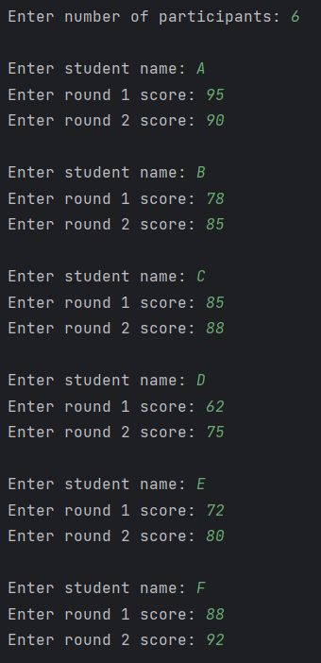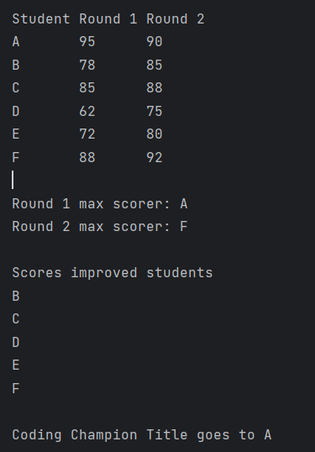

**02)**

**Source Code:**

List class:

import java.util.Arrays;  
  
public class List {  
 private int maxSize ;  
 private int position;  
 private int[] ListEntry;  
  
 public List(int size){  
 maxSize = size;  
 ListEntry = new int[maxSize];  
 position= -1;  
 }  
  
 public boolean IsListEmpty(){  
 return (position==-1);  
 }  
  
 public boolean IsListFull(){  
 return (position== maxSize-1);  
 }  
  
 public int ListSize(){  
 return (position+1);  
 }  
  
 public void InsertLast(int x){  
 if (IsListFull())  
 System.*out*.println("Attempt to insert at the end of a full list");  
 else  
 ListEntry[++position] = x;  
 }  
  
 public void InsertList(int p, int element){  
 int i;  
 if (IsListFull())  
 System.*out*.println("Attempt to insert an entry into a full list");  
 else if (p < 0 || p > ListSize())  
 System.*out*.println("attempt to insert a position not in the list");  
 else  
 {  
 for( i = ListSize(); i >p; i--)  
 ListEntry[i] = ListEntry[i-1];  
 ListEntry[p] = element;  
 position++;  
 }  
 }  
 public int DeleteList( int p) {  
 int i,element;  
 if (IsListEmpty())  
 System.*out*.println("Attempt to delete an entry from an empty list");  
 else if (p < 0 || p >= ListSize())  
 System.*out*.println("attempt to delete a position not in the list");  
 else {  
 element = ListEntry[p];  
 for( i = p; i < ListSize()-1; i++)  
 ListEntry[i] = ListEntry[i+1];  
 position--;  
 return element;  
 }  
 return 0;  
 }  
  
 int RetrieveList(int p ){  
 int i,element;  
 if (IsListEmpty()){  
 System.*out*.println("Attempt to retrieve an entry from an empty list");  
 return 0;}  
 else if (p < 0 || p >= ListSize()){  
 System.*out*.println("attempt to retrieve an entry at a position not in the list");  
 return 0; }  
 else{  
 element = ListEntry[p];  
 return element;}  
 }  
  
 public void ReplaceList (int p, int x){  
 int i;  
 if (IsListEmpty())  
 System.*out*.println("Attempt to replace an entry of an empty list");  
 else if (p < 0 || p >= ListSize())  
 System.*out*.println("attempt to replace an entry at a position not in the list");  
 else  
 ListEntry[p] = x;  
 }  
  
 public void TraverselList(){  
 int i;  
 for (i=0; i<position+1; i++)  
 System.*out*.println(ListEntry[i]);  
 }  
  
 public void sortList(){  
 Arrays.*sort*(ListEntry);  
 }  
}

MeanMedianModeRange class:

import java.util.Scanner;  
  
public class MeanMedianModeRange {  
 public static void main(String[] args) {  
 Scanner scanner = new Scanner(System.*in*);  
 System.*out*.print("Enter number length: ");  
 int len = scanner.nextInt();  
  
 System.*out*.print("Enter number sequence: ");  
 String input = scanner.next();  
  
 String[] numberStrings = input.split(",");  
 List listNumber = new List(len);  
  
 for (int i = 0; i < len; i++) {  
 listNumber.InsertLast(Integer.*parseInt*(numberStrings[i]));  
 }  
 *checkMean*(listNumber);  
 *checkMedian*(listNumber);  
 *checkMode*(listNumber);  
 *checkRange*(listNumber);  
 }  
  
 public static void checkMean(List list){  
 double total = 0, mean;  
 for (int i = 0; i <= list.ListSize()-1; i++) {  
 total += list.RetrieveList(i);  
 }  
 mean = total/list.ListSize();  
 System.*out*.println("Mean = " + mean);  
 }  
  
 public static void checkMedian(List list){  
 double median;  
 int midPosition;  
 list.sortList();  
 if (list.ListSize()%2 == 1){  
 midPosition = (list.ListSize() + 1)/2;  
 median = list.RetrieveList(--midPosition);  
 System.*out*.println("Median = " + (int) median);  
 } else if (list.ListSize()%2 == 0) {  
 int prevPosition = list.ListSize()/2 - 1;  
 int nextPosition = prevPosition++;  
 median = (double) (list.RetrieveList(prevPosition) + list.RetrieveList(nextPosition)) / 2;  
 System.*out*.println("Median = " + median);  
 }  
 }  
  
 public static void checkMode(List list){  
 int mode = list.RetrieveList(0);  
 int maxCount = 1;  
 for (int i = 0; i < list.ListSize(); i++) {  
 int count = 0;  
 for (int j = 0; j < list.ListSize(); j++) {  
 if (list.RetrieveList(i) == list.RetrieveList(j)){  
 count++;  
 }  
 }  
 if (count > maxCount){  
 maxCount = count;  
 mode = list.RetrieveList(i);  
 }  
 }  
 System.*out*.println("Mode = " + mode);  
 }  
  
 public static void checkRange(List list){  
 list.sortList();  
 System.*out*.println("Range = " + (list.RetrieveList(list.ListSize() - 1) - list.RetrieveList(0)));  
 }  
}

Output:

